2021 AA, NH & PI Roundtable Series:

The Mental Health of Asian American, Native Hawaiian & Pacific Islander Communities in the Time of COVID: It’s Time for Bold Action

PANELISTS and MODERATORS

Part 1: We Are Not the Same: Understanding the Impact of COVID and Social Injustices on the Diverse AA, NH & PI Communities
DATE: May 10, 2021 @ 2:00 - 3:30 p.m. EDT

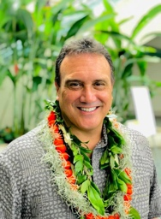
Moderator: Dr. Keawe’aimoku Kaholokula is the chair and professor of Native Hawaiian Health and deputy director for the Center of Native and Pacific Health Disparities in the John A. Burns School of Medicine at University of Hawai’i at Mānoa. His current research is funded by the National Institutes of Health to examine biological, psychological, and sociocultural factors — and their interplay — affecting Native Hawaiian and Pacific Islander health and to develop community-based and culturally relevant interventions.
Moderator: Azizah Ahmad, JD is the policy and community advocacy manager at APIA Health Forum in San Francisco, CA. Azizah has a long history of advocating for policies affecting indigenous, Southeast Asian, AA, NH & PI communities and is an active member of the Cham community. She has also had leadership roles with the National Asian Pacific American Bar Association, served as the California policy advocate at the Southeast Asia Resource Action Center, and clerked for nonprofits including the United Nations High Commissioner for Refugees in Kuala Lumpur.
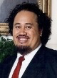
Sefa Aina is board chair of Empowering Pacific Islander Communities and associate dean and director of the Asian American Resource Center at Pomona College. He has committed his life to empowering Pacific Islanders and is actively engaged in creating access to education opportunities for Pacific Islander youth. Dr. Aina was appointed by President Obama to the President’s Advisory Commission on Asian Americans and Pacific Islanders where he served as the vice chair of the Commission from 2010 – 2014.
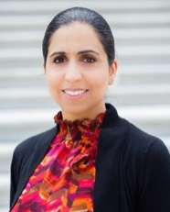
Kiran Kaur Gill is the Executive Director of SALDEF. Kiran is an accomplished professional with exemplary executive experience, she was the former president and CEO of PARS Environmental, Inc., a full-service environmental consulting firm based in Robbinsville, New Jersey. Additionally, Kiran has been a long-time advisor and volunteer for SALDEF, playing a critical role in the expansion of our Law Enforcement Partnership Program and the expansion of our SikhLEAD Internship to New Jersey.

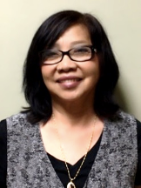
Theanvy Kuoch, MA, LPC is the founder and executive director of Khmer Health Advocates in West Hartford, CT. Theanvy is a survivor of war, torture, and genocide in Cambodia and came to the United States as a refugee in 1981. She is a nationally recognized expert on trauma and trauma-informed care. Theanvy is a family therapist and developed the Community CARES model that trains community health workers. Theanvy is partnering with the UConn Schools of Medicine, Pharmacy and Social Work to complete an NIH research project to understand the impact of culturally appropriate health promotions to prevent diabetes in traumatized people.
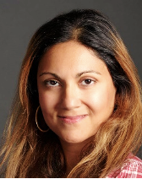
Juhi Malhotra serves on the Executive Committee of the NY Coalition for Asian American Mental Health. She is a clinical assistant professor at New York University (NYU) Silver School of Social Work, with more than 15 years of clinical experience focusing on crisis intervention, diagnostic assessments, short-term and long-term care within a multidisciplinary approach. She was also an academic and field advisor at Columbia University School of Social Work. She teaches seminars with a concentration on anti-oppression, self-awareness, and career preparation.
Jennifer Wang, JD is deputy director of programs at the National Asian Pacific Women’s Forum in Washington, DC. She is a strong advocate for women’s rights and became involved in legislative affairs for federal and state reproductive health policy, developing an expertise on birth control and preventive health services under the Affordable Care Act. She has degrees in psychology and women’s studies in addition to her JD and is passionate about the intersections of reproductive and economic justice.
Part 2: Asian American, Native Hawaiian, and Pacific Islander Self-Care and Healing
DATE: Wednesday, May 19, 2021 @ 4:00 - 5:30 pm EDT

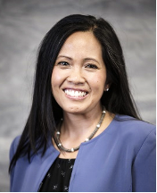
Moderator: Dr. Rachele Espiritu is a Filipina immigrant and research psychologist who centers equity in the training, technical assistance, and capacity building that she provides in the areas of behavioral health, evaluation, workforce development, systems change, and policy development. She is a founding partner with Change Matrix, a minority- and woman-owned small business that motivates, manages and measures change to support communities and systems that improve lives.
Krystle Canare is a program specialist at the Georgetown University Center for Child and Human Development. She was a senior project coordinator for the National Council for Behavioral Health; an ambassador for the White House Initiative on Asian Americans and Pacific Islanders; a health equity ambassador for the American Psychological Association; the task force fellowship director for the Filipino Young Leaders Program; advisor to the Filipino Intercollegiate Networking Dialogue, Inc.; and coach for the National Federation of Filipino American Association's Empowering Pilipino Youth through Collaboration program.
Dr. Terry S. Gock is the co-founder and director emeritus of the Asian Pacific Family Center in Los Angeles, CA. Under his leadership, APFC grew to a staff of nearly 100 providing a wide array of much-needed services. In addition to his public sector work, he is also a clinical and forensic psychologist in private practice. Dr. Gock received the Person of the Year award from Asian Pacific Americans for Human Rights as well an American Psychological Association Presidential Citation, for his lifelong devotion to multiculturalism in psychology.
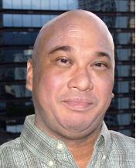
Dr. Patrick Kamakawiwo’ole is a clinical psychologist in Honolulu who works with individuals experiencing life transitions, depression, anxiety, grief, loss, nearing death, cultural challenges, sexuality, gender, and trauma. His local Hawai'i background helps him relate to strengths and differences in collectivistic communities. In addition to a humanistic theoretical frame, he is trained in eye movement desensitization and reprocessing and emotionally focused therapy. Dr. Kamakawiwo’ole works with people by using his na'au feelings and intuition; his local Chinese, Hawaiian, and local Hawai'i values; and is always open to different ways of being.
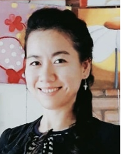
Thanh Nguyen, MSW is a Vietnamese clinician at the Asian Pacific Development Center in Denver, CO. She was born and raised in Saigon, Vietnam, and moved to Colorado in her early 20s to reunite with her father. She received her bachelor’s and master’s degrees in social work and uses her experience and knowledge of Vietnamese culture and history to guide her work as a behavioral health clinician working primarily with the Vietnamese population.
Sudarsharn Pyakurel is a former refugee from Bhutan and serves as the executive director of the Bhutanese Community of Central Ohio. He is also the founder of the Bhutanese American Students Organization, founder and managing director of Jagaran America, a Nepali Newspaper. Since coming to the United States in 2010, he has been actively working for equity, advocacy, and empowerment of refugees and immigrants. He is a member of the Trauma Responsive Care through CARE Coalition, member of the Refugee Congress, and is a Migrant and Refugee Leadership Academy fellow. In June 2018, Sudarsharn was named to the New American Advisory Committee by Ohio Governor John Kasich.
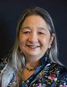
Dr. Pata Suyemoto is a feminist scholar, writer, educator, mental health activist, and a co-founder of The Breaking Silences Project. She earned her PhD. in education and did her research on multicultural education and issues of race and racism. She speaks and writes about her struggles with depression. She is a member of the Multicultural Advisory Committee for the Massachusetts Department of Mental Health and a co-chair for the sub-committee of the AAPI Anti-Stigma Campaign. Dr. Suyemoto is also an artist who is particularly interested in collage and three-dimensional found art, and she is an avid cyclist and bicycle riding instructor. During the summer of 2012, she and her partner rode their bicycles across the United States from Massachusetts to Washington State.

Part 3: What’s Next? Community Action for Transformational Change
DATE: Thursday, May 27 @ 3:00-4:30 p.m. EDT
Moderator: Dr. Larke Huang recently retired as the director of the Office of Behavioral Health Equity and a senior policy advisor at the U.S. Department of Health and Human Services Substance Abuse and Mental Health Services Administration (SAMHSA). Dr. Huang is a licensed clinical-community psychologist who has worked at the interface of policy, research, and practice in behavioral health. Her work includes reducing disparities in behavioral health care for underserved populations, working with states and counties to improve systems of care for children and youth with mental and substance use disorders, advancing trauma-informed approaches to care/recovery, and reducing the criminal/juvenile justice system for individuals with mental and substance use disorders. Dr. Huang served on the president’s New Freedom Commission on Mental Health and the Carter Center Mental Health Task Force.
Dr. Richelle Concepcion is president of the Asian American Psychological Association and a clinical Psychologist at the United States Army – Schofield Barracks Health Clinic in Hawaii.

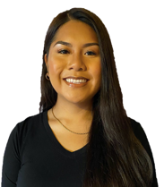
Karla Thomas, MPH of Samoan and Aymara descent, is the Co-Founder and Policy Director of the Native Hawaiian and Pacific Islander (NHPI) Data Policy Lab at the UCLA Center for Health Policy Research. She is also the lead of the Inland Empire Pacific Islander COVID-19 Response Team, based in Southern California. Her current work is focused on improving COVID-19 disparities among NHPIs in the Inland Empire by improving data and health equity, increasing access to testing and vaccines, and providing culturally congruent public health services.
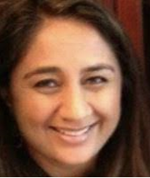
Dr. Nira Singh is Director of Behavioral Health at Asian Americans for Community Involvement and has served for over 25 years focusing on immigrant and refugee populations. She worked with Narika, a domestic violence program serving South Asian women and children in Fremont, CA, and has worked with coalitions to address cultural competency and cultural humility in the training of service providers. Dr. Singh has also been involved in developing and implementing trauma-informed and strength-based services throughout the Bay Area.
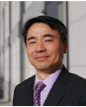
Dr. Ed K.S. Wang is assistant professor of psychology in the Department of Psychiatry at Harvard Medical School; director of policy and planning for the Chester M. Pierce, MD Division of Global Psychiatry; and board president of The National Asian American Pacific Islander Mental Health Association. He served as the director of the Office of Multicultural Affairs of the Massachusetts Department of Mental Health. Dr. Wang focuses on United States and international mental health policy, program development, and clinical excellence. He was the first Asian American psychologist appointed to the National Advisory Council for SAMHSA.
Isha Weerasinghe is a senior policy analyst at the Center for Law and Social Policy in Washington, DC, focusing on health, mental health, children, youth, families, and racial equity. Isha previously worked as the director of policy and advocacy at the Association for Asian Pacific Community Health Organizations where she focused on improving access to culturally and linguistically appropriate care for the AA, NH & PI community. Ms. Weerasinghe has done community-based participatory research, as well as local and state policy advocacy at NYU’s Center for the Study of Asian American Health.

